**Shippers Defined**

There are several types of individuals and organizations involved in the movement of sensitive items. **Freight forwarders, carriers, port authorities, waterway operators, shipping companies, air carriers, railways, and trucking companies** form the bulk of this population.

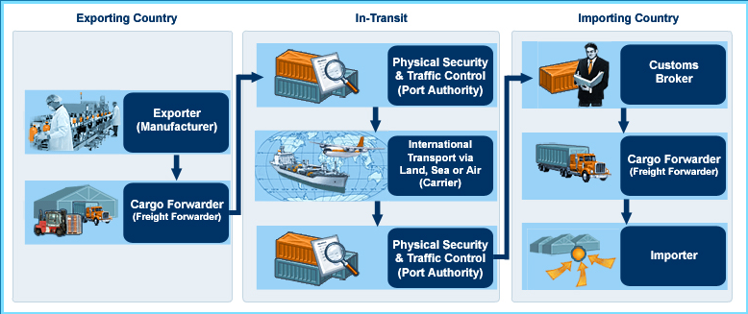While subsets within this population often interrelate, each performs different duties. Some of them are primarily responsible for moving actual cargo and others are responsible for maintaining ports, vessels, waterways, and other physical systems through which cargo passes.

The picture below provides a brief illustration of this relationship.

Shippers Defined: Shippers’ Roles

|  |  |  |
| --- | --- | --- |
| **Freight Forwarders** | **Carriers** | **Customs Brokers** |
| **Serve as agents who arrange for:**   * Shipment of goods belonging to their client/exporters * Packing Domestic and international transportation via sea, air or road * Payment of freight charges and insurance * Customs duties   **May consolidate goods at various points during transit**  **Are usually private enterprises**  **May be licensed by a government agency** | **May use their own methods of transportation**  **May partner with commercial carriers** | **Act on behalf of the importer to clear goods through customs and deliver items to the warehouse or final destination**  **Some freight forwarders are also customs brokers**  **Are usually licensed by a government agency** |

Shippers Defined: Responsibilities of an Exporter

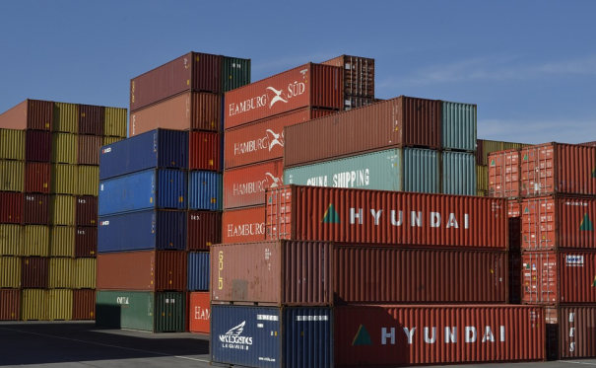

Many countries have adopted Internal Compliance Program (ICP) for exporters. An ICP is based on a corporate philosophy that says: "We want to maximize sales while also ensuring that we abide by all governmental regulations and laws and the strategic trade control standards of the international community."

Every enterprise that exports goods and services can establish an ICP to ensure that its actions do not violate the government's strategic trade control laws and regulations.

**Responsibilities of the exporter with regards to strategic trade controls are to:**

* Determine commodity classification of the item(s) to be shipped
* Determine whether the item requires an export license or if it can be exported under a license exception
* Conduct end-use/end-user screening
* Submit complete and accurate license application to the appropriate government authority
* Accurately complete the export documentation
* Maintain records as maintained by national legislation

Shippers Defined: Responsibilities of a Shipper

United Nations Security Council Resolution (UNSCR) 1540 states that in order to stem the proliferation of sensitive items, a country needs to establish, develop, review, and maintain appropriate effective national export/transit controls. In addition, the country has to establish and enforce appropriate **criminal or civil penalties for violations of strategic trade control laws** and regulations. Below are several examples of transit controls and penalties for acts of non-compliance.

**United States**

****The U.S. Export Administration Regulations (EAR) places legal responsibility on all persons who have information, authority, or functions relevant to carrying out export transactions subject to the EAR.

* Forwarding agents may have compliance responsibilities under the EAR even when their actions are dependent upon information or instruction given by those who use his/her services.
* Under the EAR, misrepresentations and false statements on export documents can result in penalties up to $125,000 to $250,000 per offense (depending on whether or not the violation is voluntarily disclosed).

**Japan**

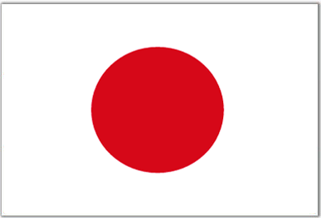Japan’s *Foreign Exchange and Foreign Trade Act* stipulates specific penalties for strategic trade control violations, including the unauthorized transit of strategic items.

* Penalties violations involving WMD proliferation can include prison terms up to **10 years**
* Penalties for violations not related to WMD proliferation can result in prison terms of up to **7 years**

**Estonia**

* In Estonia, transit shipments must be licensed when the dual-use goods are carried though Estonia from a country outside of the EU to another country, or if **military-related goods** are carried through Estonia regardless of their final destination.
* Violations of these controls can result in **administrative and financial penalties**. Fines in Estonia range up to **3,205 Euros**.

**Hong Kong Special Administrative Region**

* 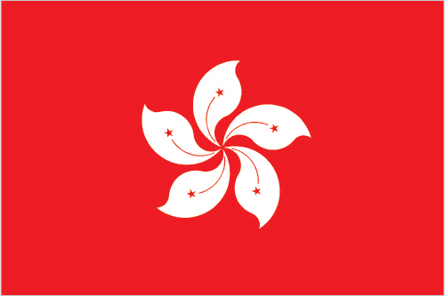The *Import and Export Ordinance,* Section 2 defines an ‘**article in transit**’ as an article which- (a) is brought in to Hong Kong solely for the purpose of taking it out of Hong Kong; and (b) remains at all times in or on the vessel or aircraft in or on which it is brought into Hong Kong”
* Section 6A: “An article in transit” [listed in Schedule 2*] requires a license issued by the Director. An offense “is liable on summary conviction to a fine of $500,000 and to imprisonment for 2 years; and on conviction on indictment to an **unlimited fine** and to **imprisonment for 7 years.”** Note: *A license is necessary for the transit of items found in Schedule 2. Schedule 2 is comprised of certain munitions, nuclear, and nuclear dual-use items; WMD-relevant items and related technical information.*